Exercise 1  
  
**Part A:** Create a database named Quality_Software

CREATE DATABASE Quality_Software;

OR

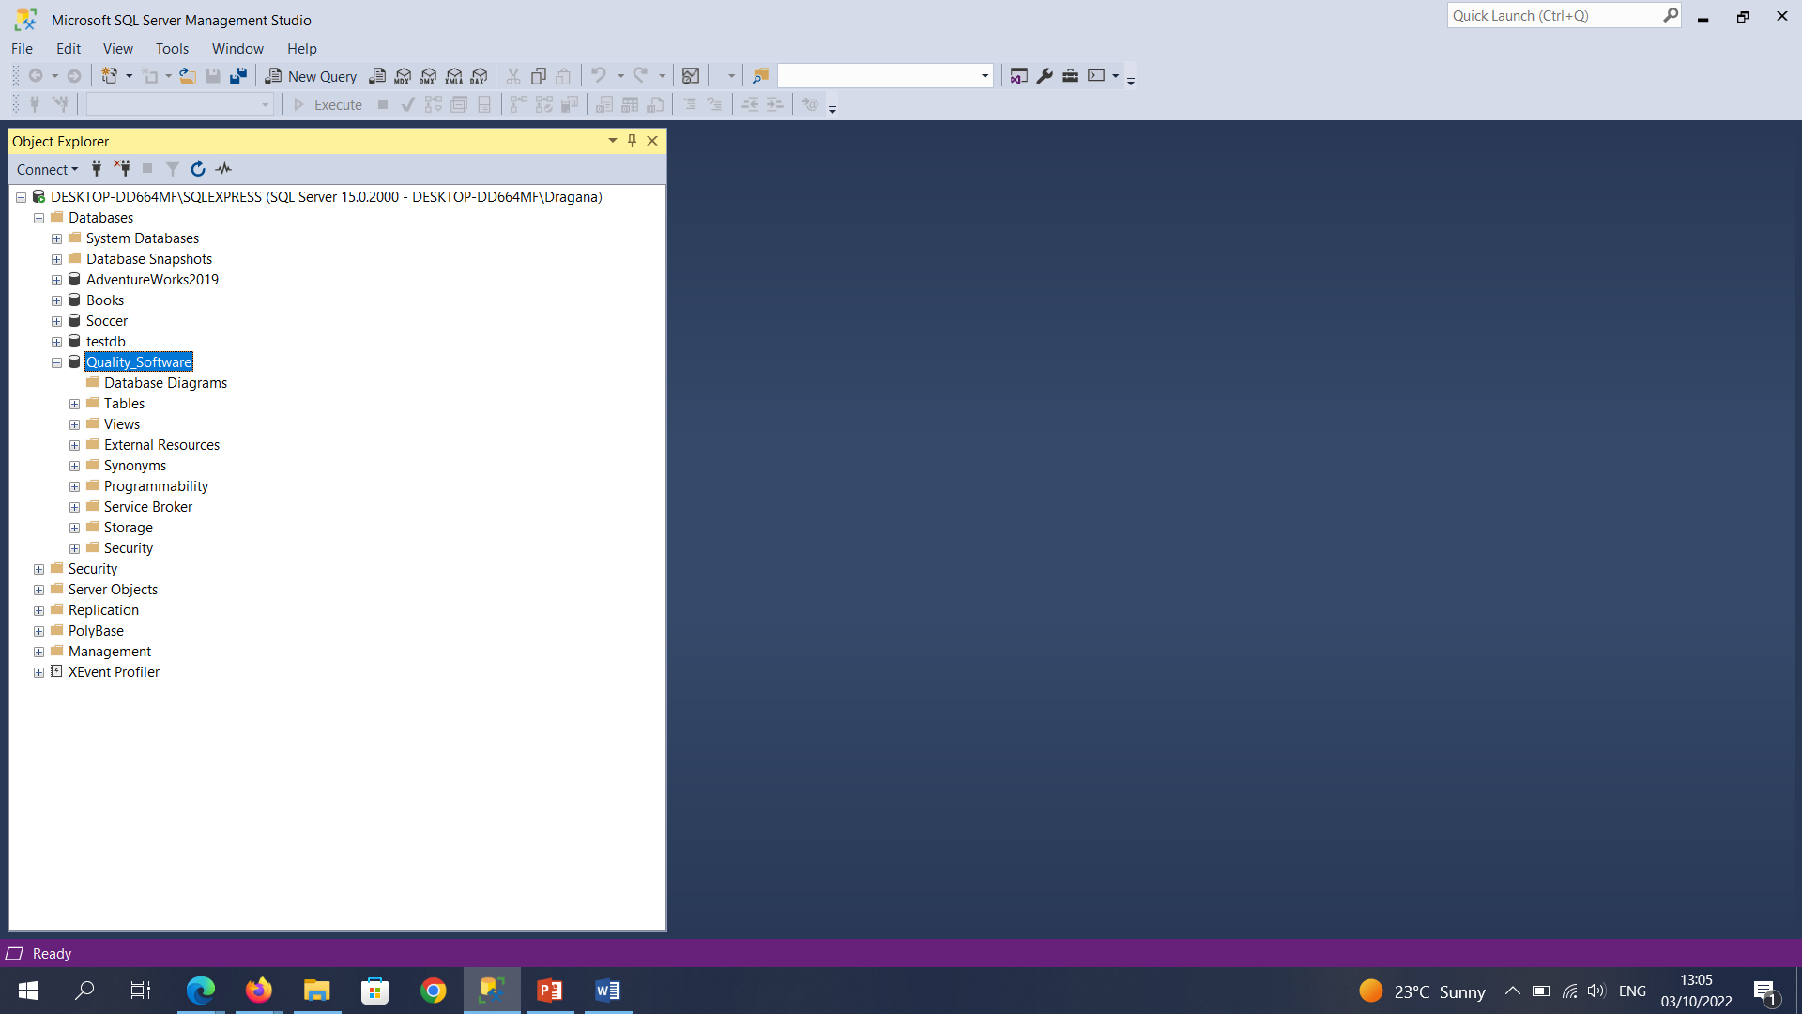

Showing the steps (I forgot to take screenshots when I initially did this step).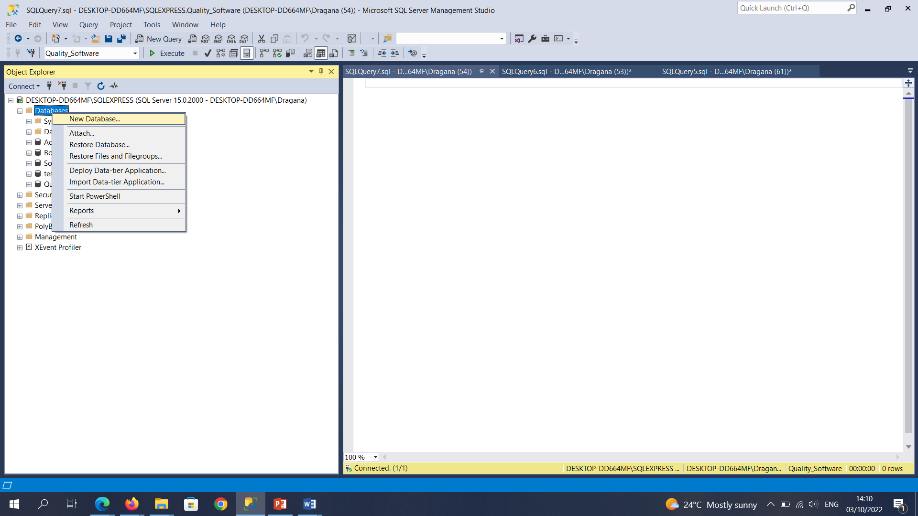

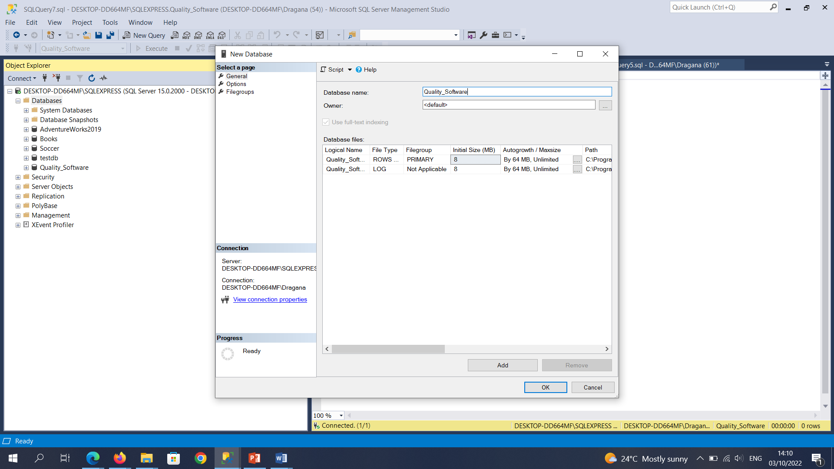

**Part B:** Create the following tables with the stated fields.

Customers  
customerId int NOT NULL, (PRIMARY KEY)  
companyName varchar(50) NOT NULL  
address1 varchar(50) NOT NULL  
address2 varchar(50) NOT NULL  
city varchar(50) NOT NULL  
country varchar(50) NOT NULL  
contactName varchar(50) NOT NULL  
contactEmail varchar(50) NOT NULL  
Contractors  
contractorId int NOT NULL, (PRIMARY KEY)  
firstName varchar(50) NOT NULL  
lastName varchar(50) NOT NULL  
address1 varchar(50) NOT NULL  
address2 varchar(50) NOT NULL  
city varchar(50) NOT NULL  
country varchar(50) NOT NULL  
contactPhone varchar(50) NOT NULL  
contactEmail varchar(50) NOT NULL

CREATE TABLE Customers (

CustomerId int NOT NULL PRIMARY KEY,

CompanyName varchar(50) NOT NULL,

Address1 varchar(50) NOT NULL,

Address2 varchar(50) NOT NULL,

City varchar(50) NOT NULL,

Country varchar(50) NOT NULL,

ContactName varchar(50) NOT NULL,

ContactEmail varchar(50) NOT NULL

);

CREATE TABLE Contractors (

ContractorId int NOT NULL PRIMARY KEY,

FirstName varchar(50) NOT NULL,

LastName varchar(50) NOT NULL,

Address1 varchar(50) NOT NULL,

Address2 varchar(50) NOT NULL,

City varchar(50) NOT NULL,

Country varchar(50) NOT NULL,

ContactPhone varchar(50) NOT NULL,

ContactEmail varchar(50) NOT NULL

);

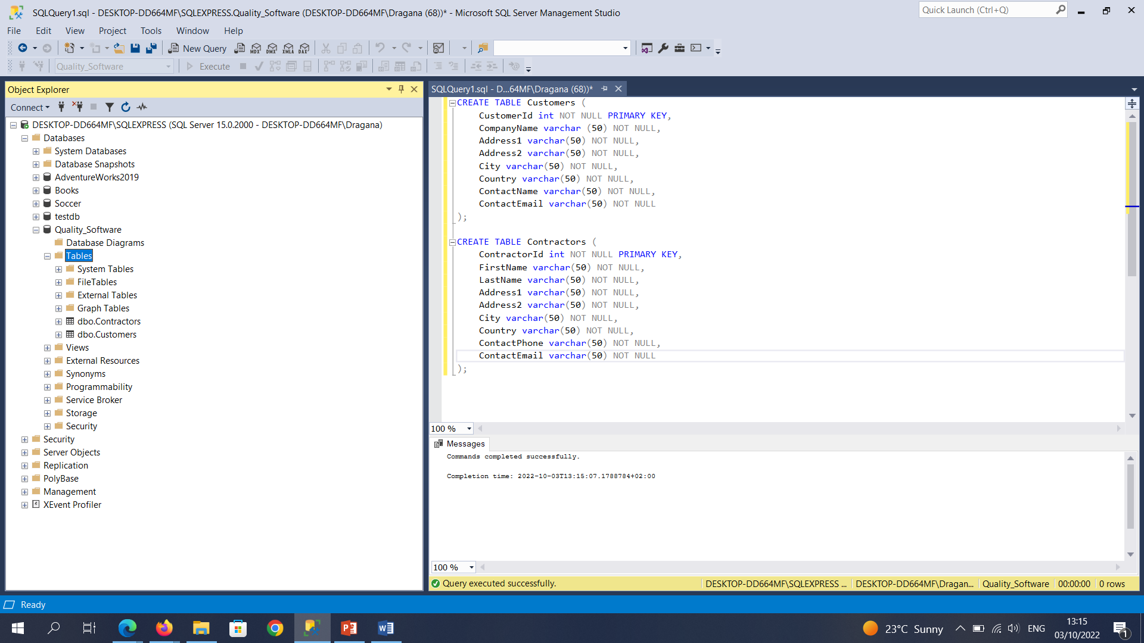

**Part C:** Insert the following records.

Customers  
(1, 'German Motors','22 Strabe Munchen', 'Munchen Klien', 'Munich',  
'Deutscheland', 'Michael Schmidt', 'michaelschmidt@gmmotors.com')  
(2, 'Das Auto', '100 Munchen Business Park', 'Munchen 2323', 'Munich',  
'Deutscheland', '4987545332', 'Philip Kroos@dasauto.com')  
(3, 'Danone','15 Parkway House', 'Leicester Road', 'Leicester', 'England',  
'055455434', 'jamietaylor@danone.com')  
(4, 'Nestle','13 Rue de Paris', 'Paris', 'Paris 201212', 'France',  
'49875545454', 'michelegaulle@nestle.com')

Contractors  
(1, 'Hans', 'Christian','12 Strabe Munchen', 'Munchen Klien', 'Munich',  
'Deutscheland', '4987565656', 'hanschristian@hotmail.com')  
(2, 'Karl Heinz', 'Vakkel','10 New Forrest Strabe', 'Munchen Grob', 'Munich',  
'Deutscheland', '4987549543', 'karlheinz@hotmail.com')  
(3, 'Anne', 'Leicester','54 Emmerdale Road', 'Emmerdale Farm', 'Emmerdale',  
'England', '055454545', 'anneleicester@hotmail.com')  
(4, 'Peter', 'Rummeniege','13 Hamburg Way', 'Hamburg', 'Hamburg', 'Germany',  
'4987545454', 'peterrummeniege@hotmail.com')

INSERT INTO Customers (CustomerId, CompanyName, Address1, Address2, City, Country, ContactName, ContactEmail)

VALUES (1, 'German Motors','22 Strabe Munchen', 'Munchen Klien', 'Munich',

'Deutscheland', 'Michael Schmidt', 'michaelschmidt@gmmotors.com');

INSERT INTO Customers (CustomerId, CompanyName, Address1, Address2, City, Country, ContactName, ContactEmail)

VALUES (2, 'Das Auto', '100 Munchen Business Park', 'Munchen 2323', 'Munich',

'Deutscheland', '4987545332', 'Philip Kroos@dasauto.com');

INSERT INTO Customers (CustomerId, CompanyName, Address1, Address2, City, Country, ContactName, ContactEmail)

VALUES (3, 'Danone','15 Parkway House', 'Leicester Road', 'Leicester', 'England',

'055455434', 'jamietaylor@danone.com');

INSERT INTO Customers (CustomerId, CompanyName, Address1, Address2, City, Country, ContactName, ContactEmail)

VALUES (4, 'Nestle','13 Rue de Paris', 'Paris', 'Paris 201212', 'France',

'49875545454', 'michelegaulle@nestle.com');

INSERT INTO Contractors (ContractorId, FirstName, LastName, Address1, Address2, City, Country, ContactPhone, ContactEmail)

VALUES (1, 'Hans', 'Christian','12 Strabe Munchen', 'Munchen Klien', 'Munich',

'Deutscheland', '4987565656', 'hanschristian@hotmail.com');

INSERT INTO Contractors (ContractorId, FirstName, LastName, Address1, Address2, City, Country, ContactPhone, ContactEmail)

VALUES (2, 'Karl Heinz', 'Vakkel','10 New Forrest Strabe', 'Munchen Grob', 'Munich',

'Deutscheland', '4987549543', 'karlheinz@hotmail.com');

INSERT INTO Contractors (ContractorId, FirstName, LastName, Address1, Address2, City, Country, ContactPhone, ContactEmail)

VALUES (3, 'Anne', 'Leicester','54 Emmerdale Road', 'Emmerdale Farm', 'Emmerdale',

'England', '055454545', 'anneleicester@hotmail.com');

INSERT INTO Contractors (ContractorId, FirstName, LastName, Address1, Address2, City, Country, ContactPhone, ContactEmail)

VALUES (4, 'Peter', 'Rummeniege','13 Hamburg Way', 'Hamburg', 'Hamburg', 'Germany',

'4987545454', 'peterrummeniege@hotmail.com');

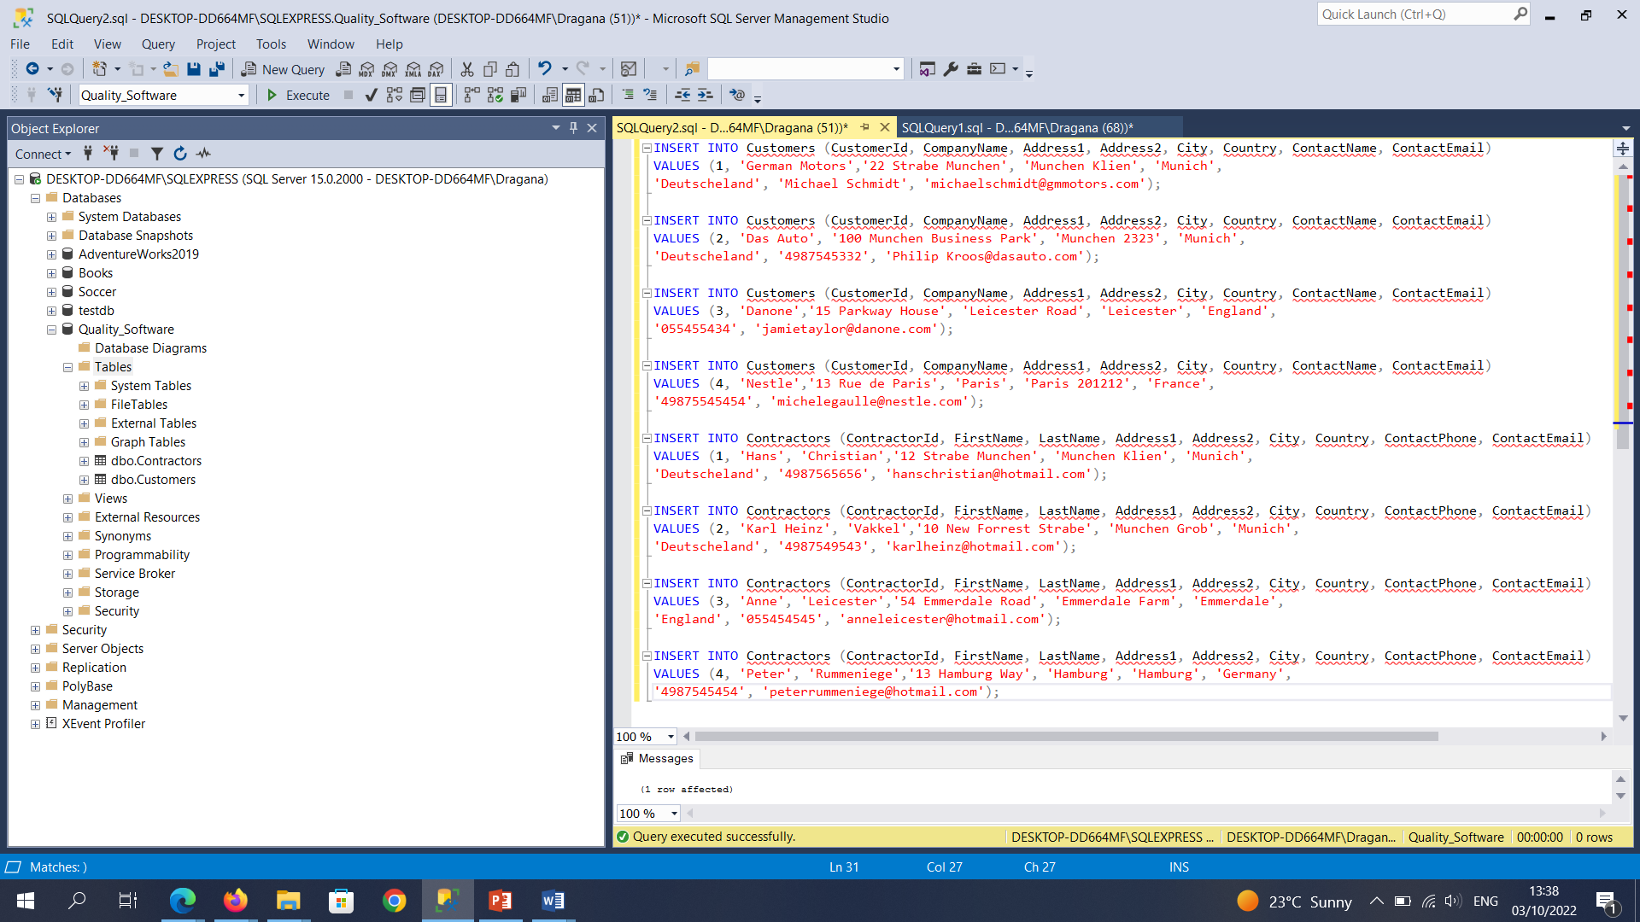

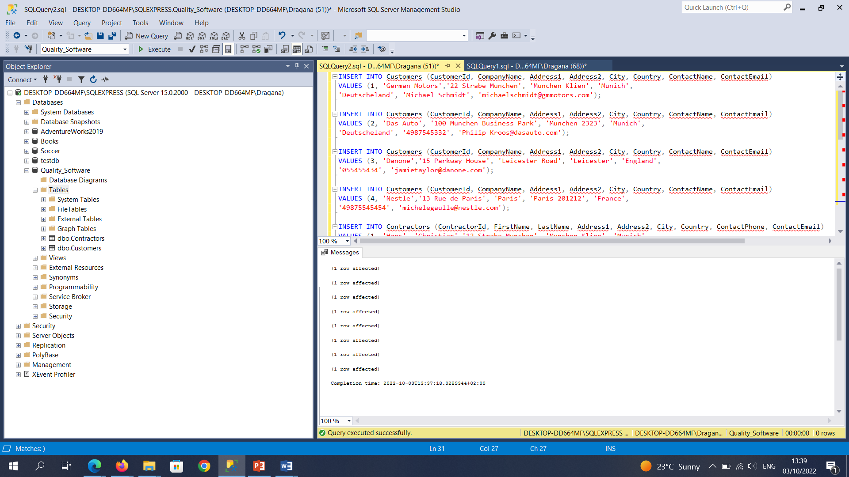

**Part D:** Update the following records:

Contractors  
• For the contractor with the contractorId value of 2, change the email address to read: [karlheinz@gmail.com](mailto:karlheinz@gmail.com)

UPDATE Contractors

SET ContactEmail = 'karlheinz@gmail.com'

WHERE ContractorID = 2;

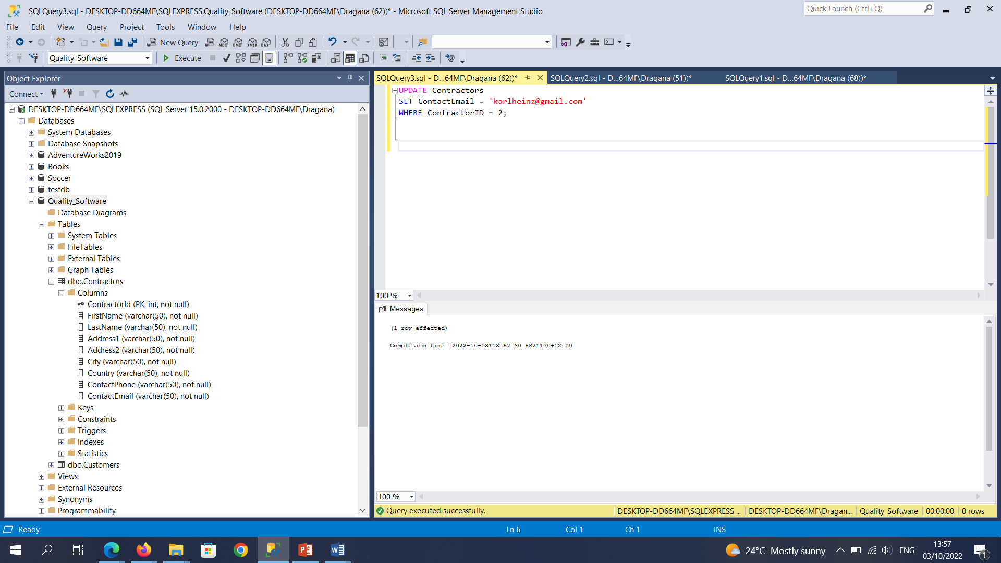

Customers  
For the customer with the customerId value of 3, change the company name to Group  
Danone.

UPDATE Customers

SET CompanyName = 'Group Danone'

WHERE CustomerID = 3;

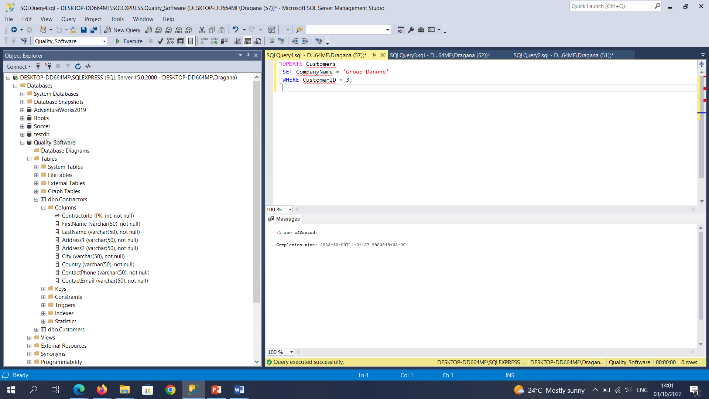

**Part E:** In the Contractors table, delete the record where the field contractorId has a value of 3.

DELETE FROM Contractors WHERE ContractorID = 3;

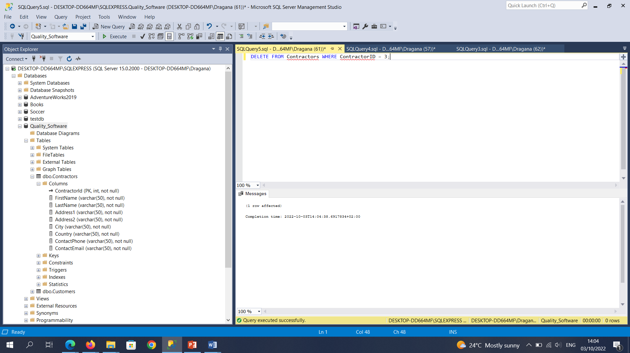

Final Tables – Exercise 1:

